

DSO 545 Project Report



**Group 17**

Mi Su

Shuyi Tao

Ying Chen

Tzu-Yi Huang

Chinkai Huang

Table of Contents

Background and Data Introduction 3

Data Visualization and Analysis 3

Prediction 18

Conclusion and Recommendation 22

# **Background and Data Introduction**

* **Los Angeles Homeless Background**

1. **Background**

The phenomenon of homelessness has been one of the most serious problems in Los Angeles for many years. In 2016, Los Angeles reported the largest number of chronically homeless people in the nation for continuous two years. The number of sheltered homeless was nearly 13000 at that time, 95% of them live in outdoors, in cars, tents and encampments. In 2017, the number of homeless in LA county goes up sharply, the increasing percentage (Chart 1) of homeless people this year is almost 4 times of the earlier year.

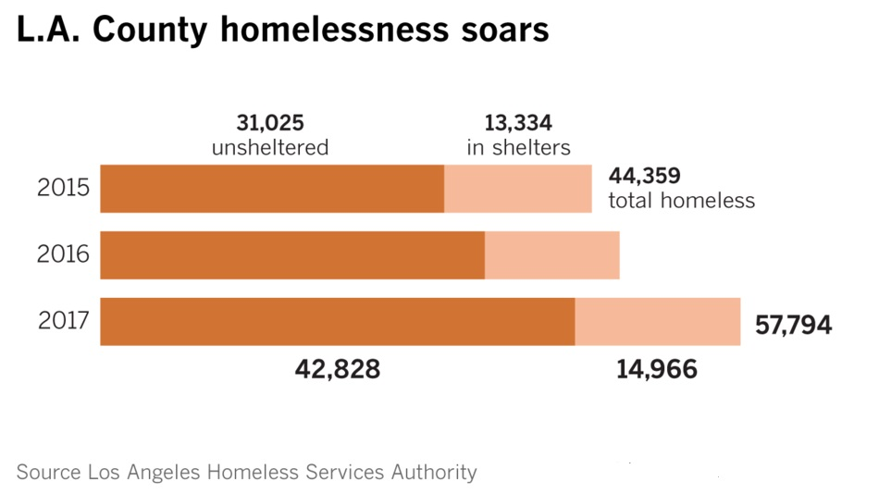

Chart 1 Number of Homeless People in Los Angeles

1. **Issue Identified**

As the city is allocating the resources to the homeless, the challenge it facing now is how to prioritize the area of high concentration with homelessness as well as with high danger and health risk. So, this is what our project aims to solve.

* **Data We Used**

The datasets we used are the 5 listed, LAHSA PIT count geospatial data, Homeless Count 2017 results by census tract, 311 calls, shelters and crimes, which are all sourced from city of Los Angeles.

# **Data Visualization and Analysis**

* **2017 Homeless Count**

1. **General Homeless Distribution**

The first thing we want to know is about the distribution of homeless people in Los Angeles. So we draw a chart (Chart 2) based on Based on LAHSA PIT count geospatial data, In order to identify the location of homeless concentrated area, we combine this chart with Google map (Chart 3).

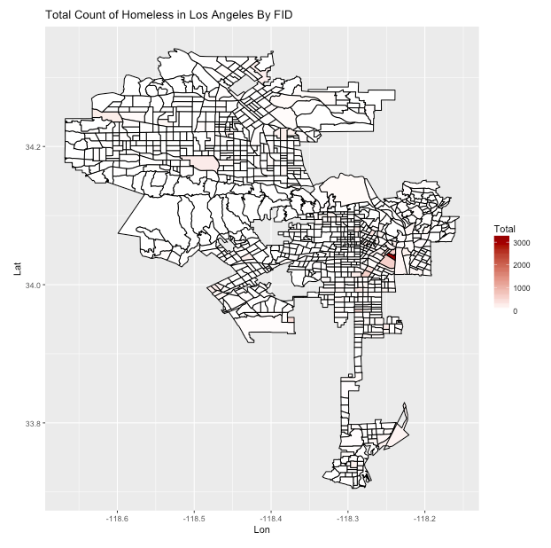

Map 1 Total Count of Homeless Distribution in L.A

From this map, we find the homeless people are mainly concentrated in the red and pink area, while in red area, the density is the largest.

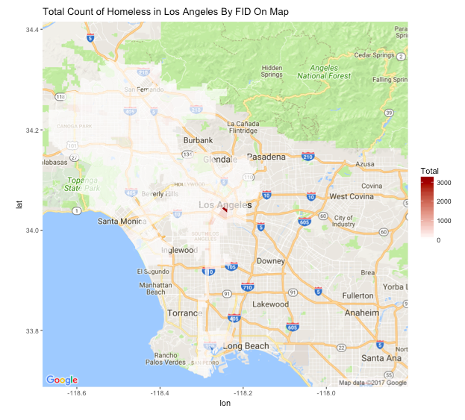

Map 2 Total Count of Homeless Distribution in L.A with Google Map

After putting Map 1 on google map (Map 2), we find that red area is just downtown in Los Angeles, which also matches the current situation in Los Angeles.

**2) Top 10 Homeless Community Distribution**

Knowing the general homeless distribution in L.A, the next thing we do is to position the communities with most number of homeless people and explore the change on homeless number in these communities in recent years. So we made another two graphs – Map 3 and Chart 2.

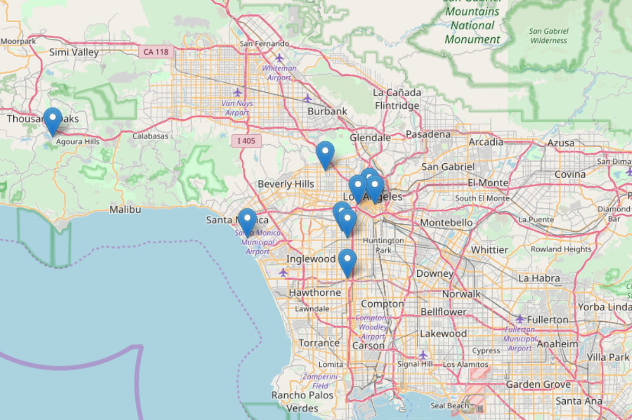

Map 3 Top 10 Homeless Community Distribution in L.A

From this chart, we can clearly locate the top 10 homeless communities . As what we expect, we find most of which are also concentrated in downtown in L.A.

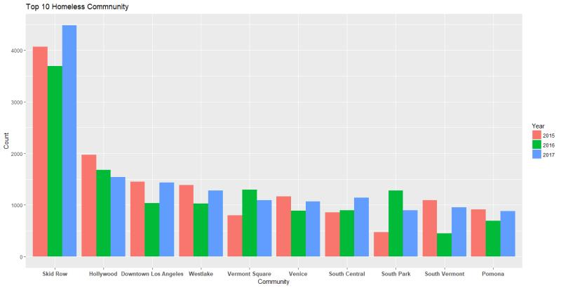

Chart 2 Total Count of Homeless People in Top 10 Homeless Community in L.A in 2015-2017

This chart allows us to compare the total number of homeless people in top 10 homeless communities in the year from 2015 to 2017.We can see the number of homeless people have no big changes and have kept stable in these years, except Hollywood, the number of which is decreasing these 3 years. While the community Skid Row has the largest number of homeless people, far more than other communities, which is our targeted rescuing area.

* **Shelter Distribution and Shelter Allocation**

From the previous part, we have found that homeless are not evenly distributed among Los Angeles. In this part, based on the goal that City of LA has set, which is reducing unsheltered Angelenos by 50% in five years, we would like to see the distribution of unsheltered homeless people and the distribution of shelter resources. Furthermore, we built models and hoped these models can help better allocate shelter resources.

1. **Current Shelter Location**

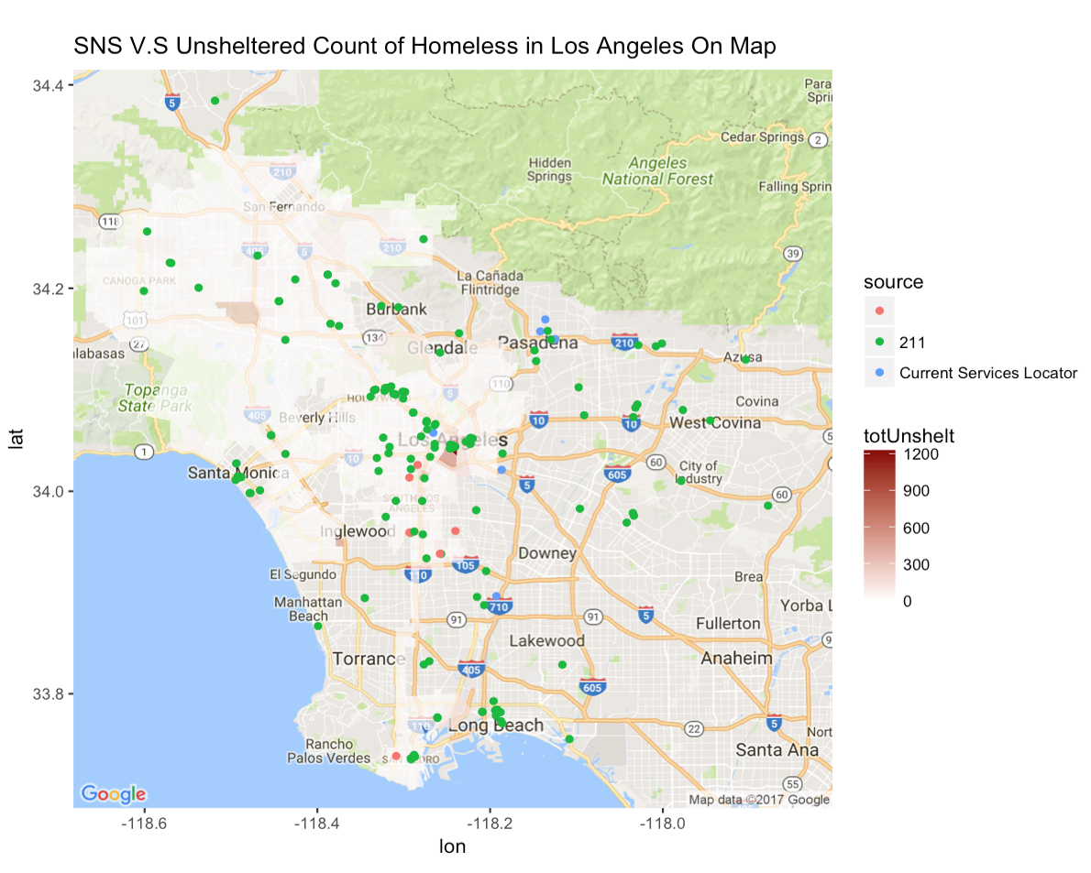

Map 4 SNS V.S Unsheltered Count of Homeless in Los Angeles on Map

On this map, we focused on researching the distribution of shelters and the distribution of unsheltered homeless people. From this distribution map, we discovered that shelter resources are not evenly distributed to those highly unsheltered area. Many shelters are located far away from the high-density unsheltered homeless area. The uneven distribution of shelters might lead to inefficient homeless allocation which may yield high unsheltered rate. In the following part, we will talk more about how we come up with a model to help efficiently allocate homeless to each shelter.

1. **311 Request and Current Shelter Allocation**

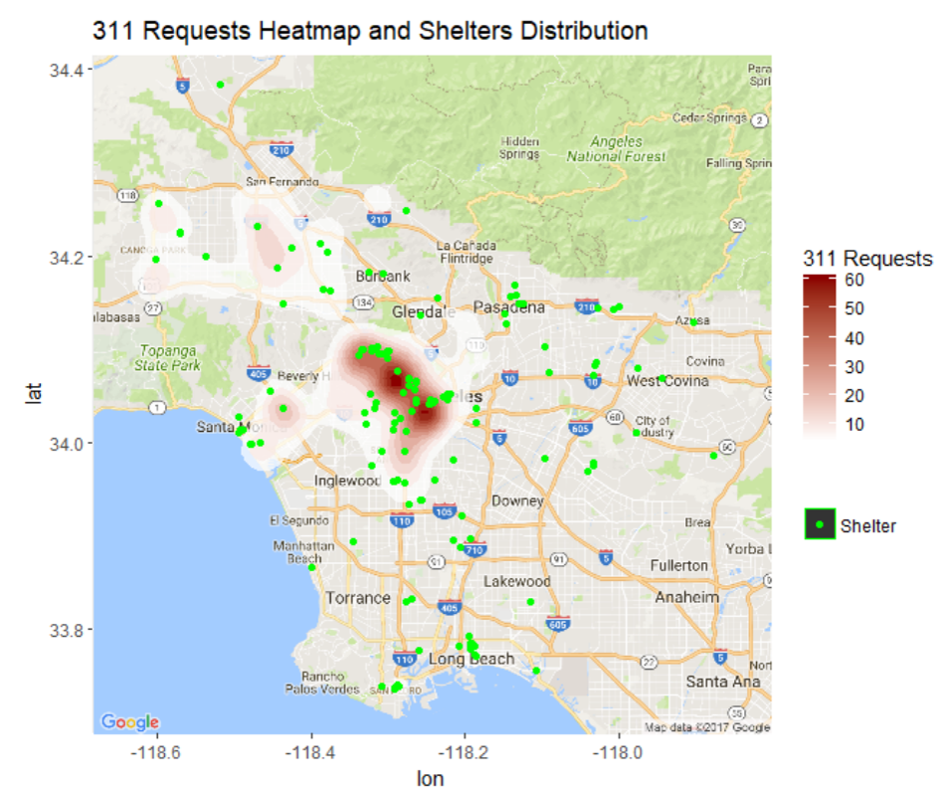

Map 5 311 Request Heatmap and Shelters Distribution

In order to see how can we allocate resources efficiently, we first have to know the distribution of 311 requests call and shelters. In 311 call dataset, every request represents homeless encampment request. We visualized this information on a map by drawing a heatmap distribution. The darker the area, the more requests the area had over the past year. Comparing with the shelter distribution, most shelters locate in the area where there are fewer 311 requests. Hence, we decided to build models to efficiently allocate these homeless to the best shelter location.

1. **Building Models for Shelter Allocation**

From previous parts, we have seen the distribution of unsheltered homeless and shelters. Ideally, we should build more shelters. However, in real world, building shelters takes a lot of time and money. Thus, we focus on optimization of current resources since we have to deal with around 20,000 311 request calls each year.

Before building model, we have basic assumptions:

* Each 311 request call represents one homeless
* Each 311 request call happened at the same place where the homeless stayed
* Since we don’t have any information of each shelter, we assume all shelters don’t have any restriction.
* All shelters have the same capacity and are now vacant and free for allocation.

We take USC neighborhood as an example. There are 6 shelters around USC.

**A. Distance Model**

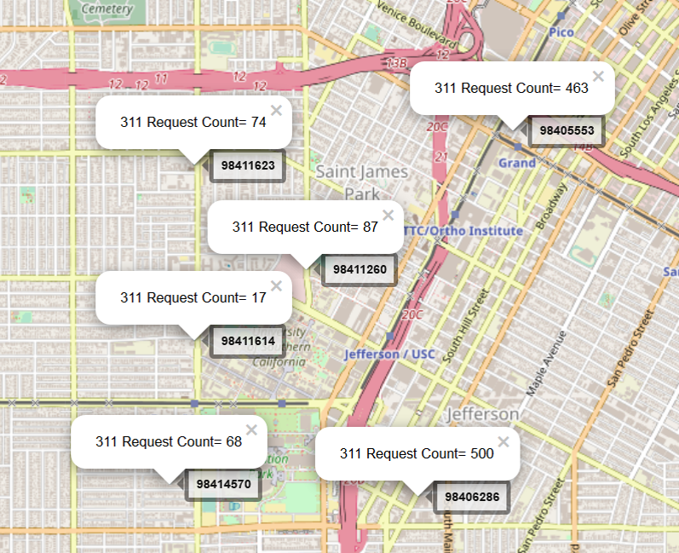

Map 6 Results after Using Distance Model

Our first model takes distance as an indicator. Basically, we assign each 311 call to the nearest shelter. This model is simple and quick. However, as you can see from the picture above, this model has a poor allocation of shelter resources.

**B. Score Model**

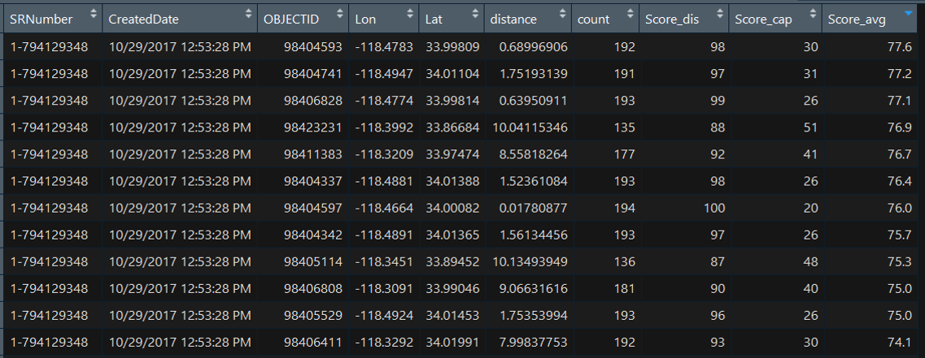

Table 1 Score Model

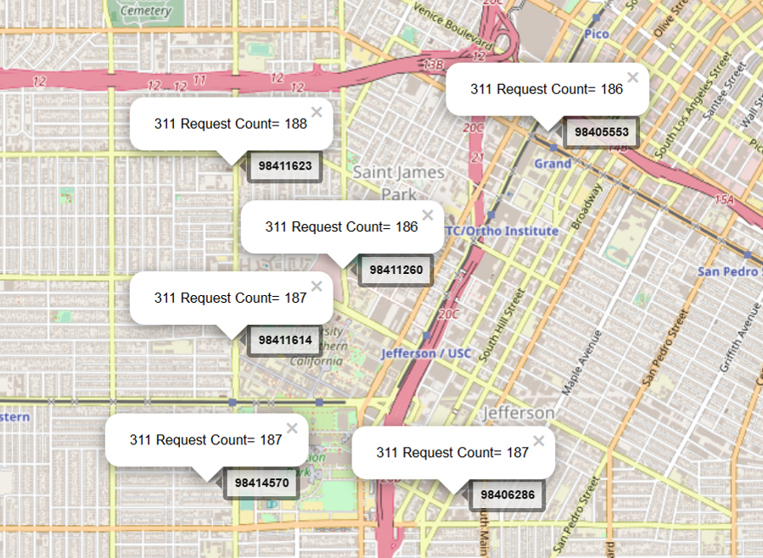

Map 7 Results after Using Score Model

Our second model takes distance and capacity as indicators. To effectively utilize shelter resources, we create a score for each shelter. This score takes the two indicators into account. In the picture above, the OBJECTID stands for different shelters. Whenever a 311 request comes in, we calculate a weighted-average score for each shelter, based on the distance and the capacity of the shelter at that time. Then, we allocate homeless people to the shelter with highest score. We can see the result from the map above that homeless people are more evenly distributed through this model than through previous model. This model has optimized the allocation of shelter resources. However, this model requires a realistic scoring methods and is very time-consuming.

1. **Comparing Models**

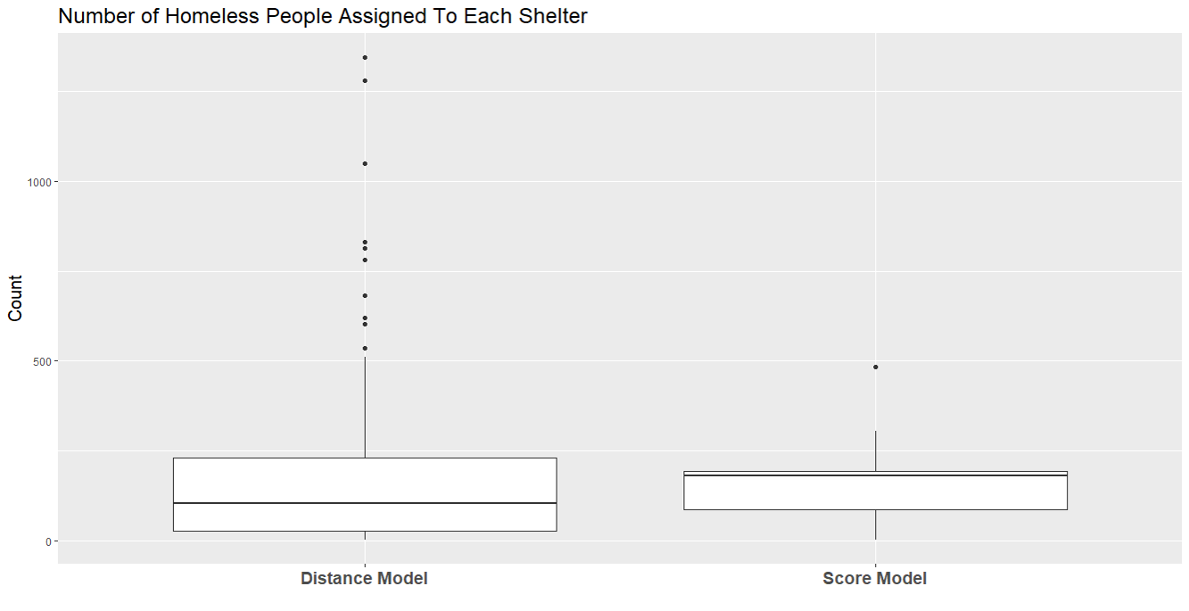

Chart 3 Number of Homeless People Assigned to Each Shelter

From allocation point of view:

The y-axis is the number of homeless people assigned to each shelter. The maximum of the score model is around 500 and the variation is much smaller than that of the distance model. This indicates that score model performs better on evenly allocating shelter resources.

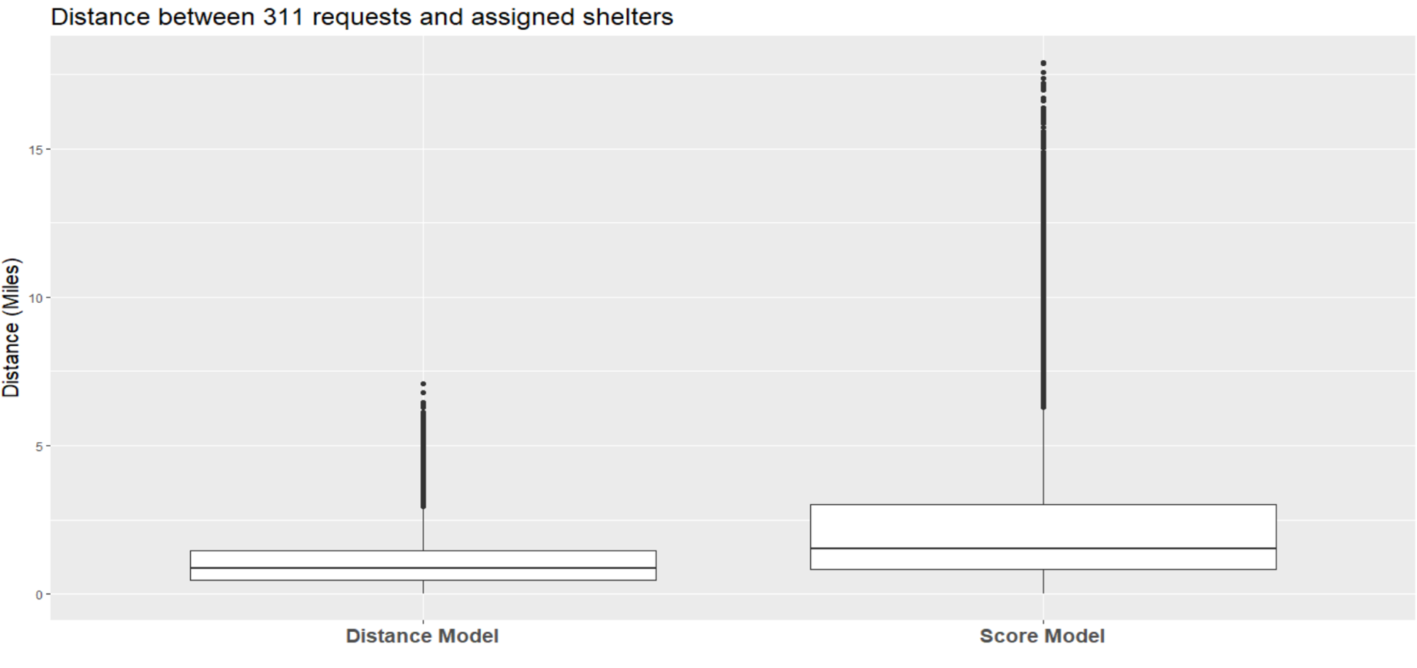

Chart 4 Distance between 311 Requests and Assigned Shelters

From distance point of view:

The y-axis here is the distance between each 311 call and its shelter assigned. If we consider distance as our first priority, distance model yields a better result since the variation is much smaller than that of a score model.

There is a tradeoff between distance and capacity. Under the score model, some homeless people are allocated to more distant shelters but still most of them (about 75%) are assigned to shelters within a 3 miles range, which seems acceptable. Besides, outliers can be reduced by imposing an upper limit of distance. Moreover, depends on what authority values most, we can generate different results by changing the weights and scoring method.

1. **Conclusion & Model Improvement**

In conclusion, visualization of these data help us identify potential issues of unevenly distributed resources to the unsheltered, and building model help us improve the allocation of shelter resources. However, since we don’t have much information for shelters and each 311 request call, these models were built on the basis of a variety of assumptions. In other words, the models are not ready to be applied to real world cases. Nevertheless, if there are more data related to attributes of each shelter and each 311 request call, for example, the restriction, the maximum capacity and the current capacity of each shelter, we can take these factors into consideration and make our model more realistic.

* **Crime**

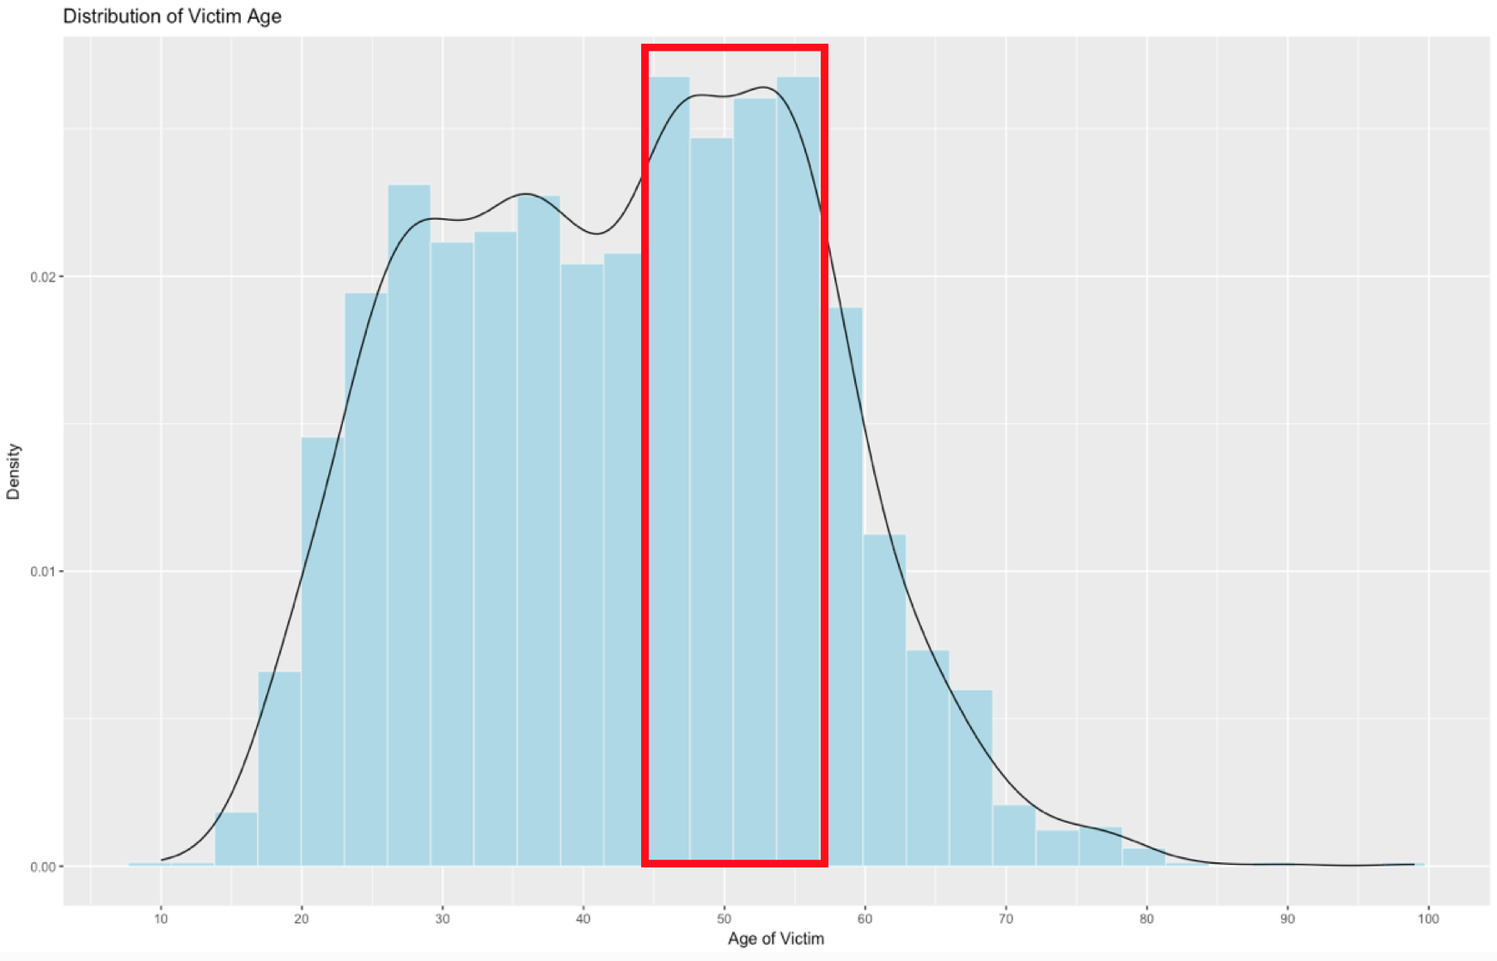

Chart 5 Distribution of Victim Age

This is a bar chart showing the distribution of the homeless victim's age. The line shows the density of the age distribution. We can see from the graph that there is a peak at the age range from 44 to 57. One reason to explain this is that there may be more homeless people around this age range. Or, it is true that people in this age range are more vulnerable to crimes.

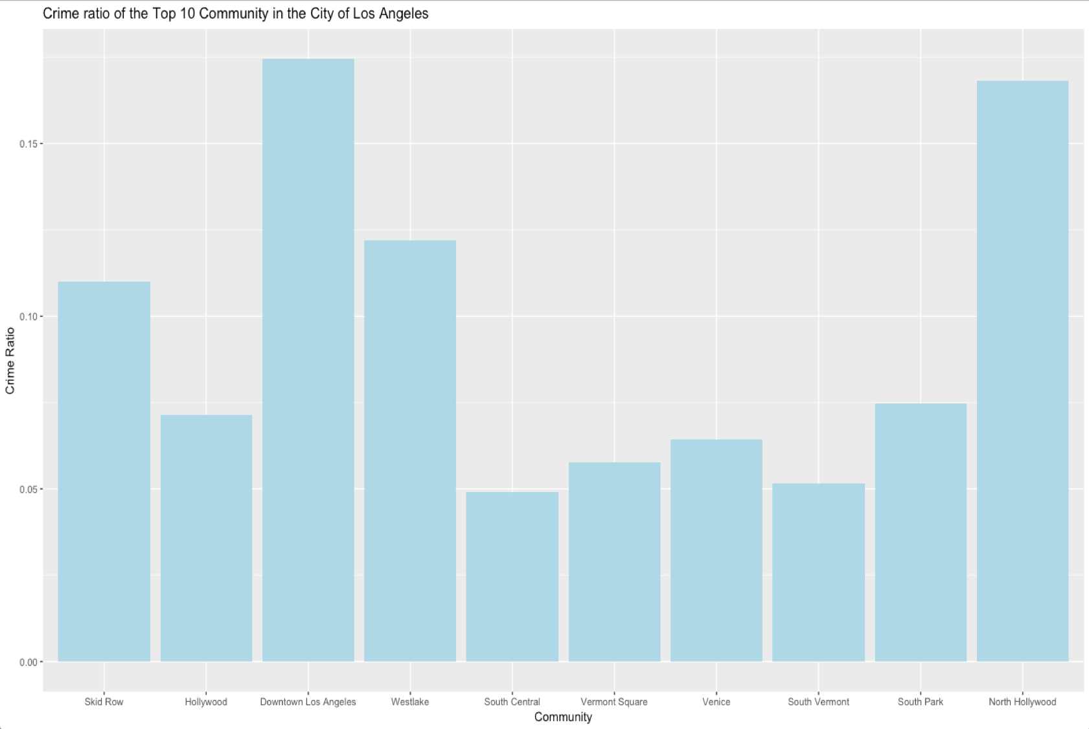

Chart 6 Top 10 Homeless Community - Crime Ratio

Previously, we have mentioned these top 10 communities that have the largest number of homeless people in 2017. Comparing previous graph with this graph that shows the crime ratio for each community, using the number of crime happened in each community divided by the number of total homeless people in each community, we notice that there is no direct relationship between crime ratio and the total number of homeless people. Communities such as Downtown LA, Westlake and North Hollywood have relatively high crime ratio. This is an issue that needs to be pay attention to. The City should take a deeper look at what causes the high crime ratio in these communities.

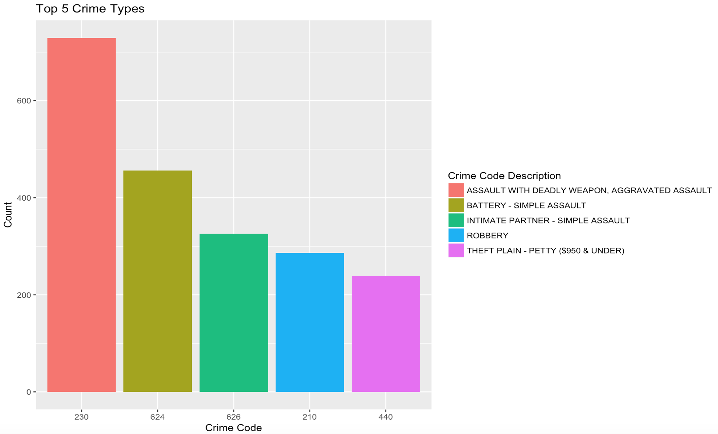

Chart 7 Top 5 Crime Types

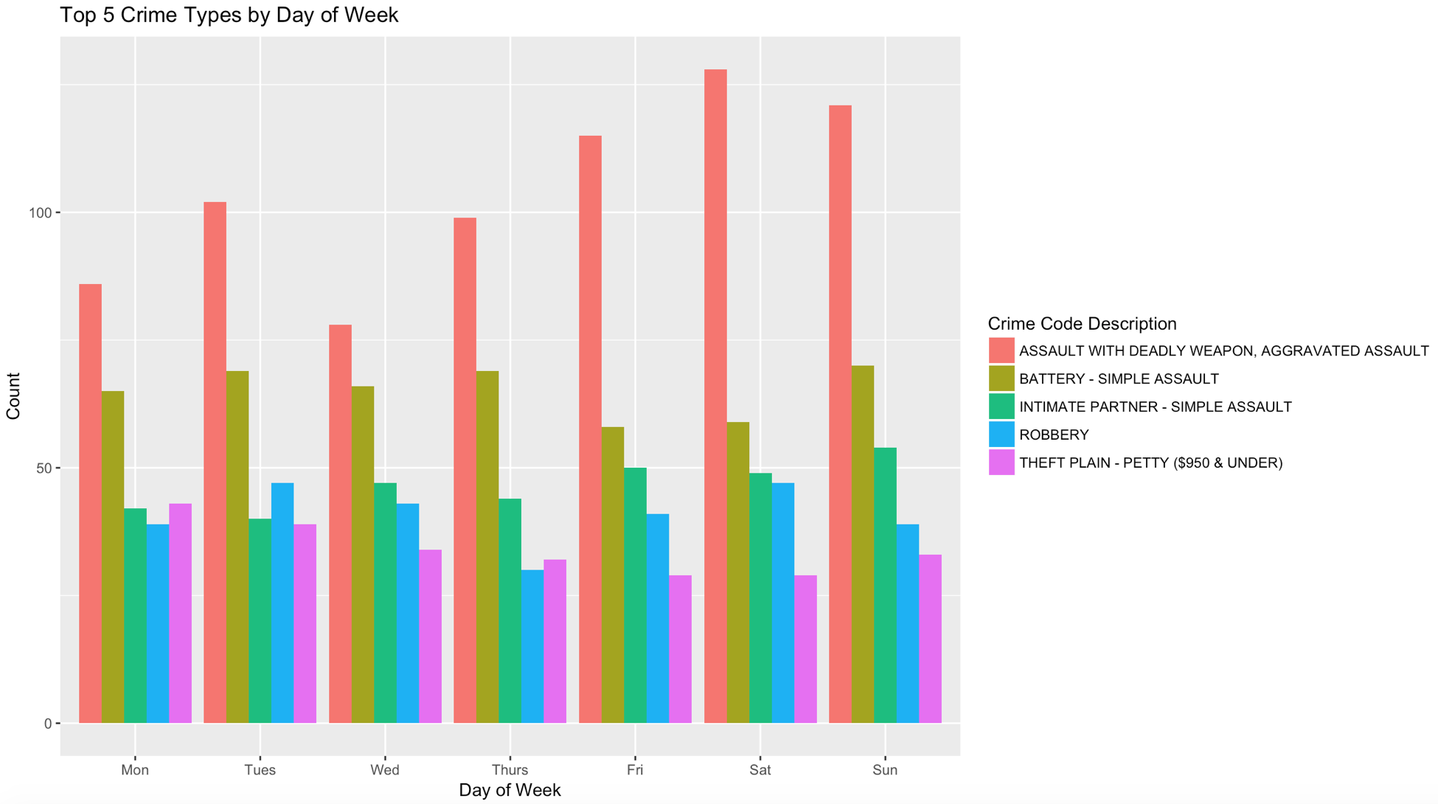

Chart 8 Top 5 Crime Types by Day of Week

This a graph (Chart 7) showing top five crime types that have the largest number of count. To go deeper, we figure out the top 5 crime types for each day of the week (Chart 8). One thing to notice is that even though the number of crime varies each day, the top 5 crime types remain the same. They are assault with deadly weapon, battery, intimate partner, robbery and theft plain. The assault with deadly weapon and battery are steadily the top 2 crimes for each day. This maybe because the frequencies of the top two crime type are really higher than the others, or maybe because there are more crimes being allocated to these two types. Either way, I believe the City should have some regulation enforcements or strengthen the police in specific areas to prevent more crimes from happening.

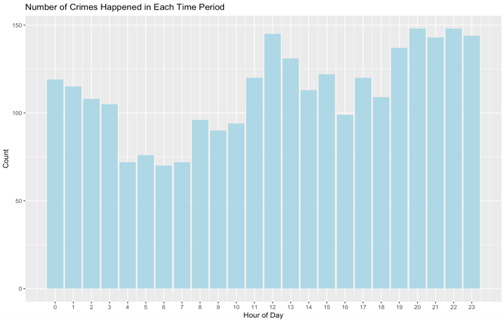

Chart 9 Number of Crimes Happened in Each Time Period

We also figure out the number of crime happened in each time period of the day and noticed that there are two peaks in a day: one is at around noon, and the other one peak is from 7 to 11 at night.

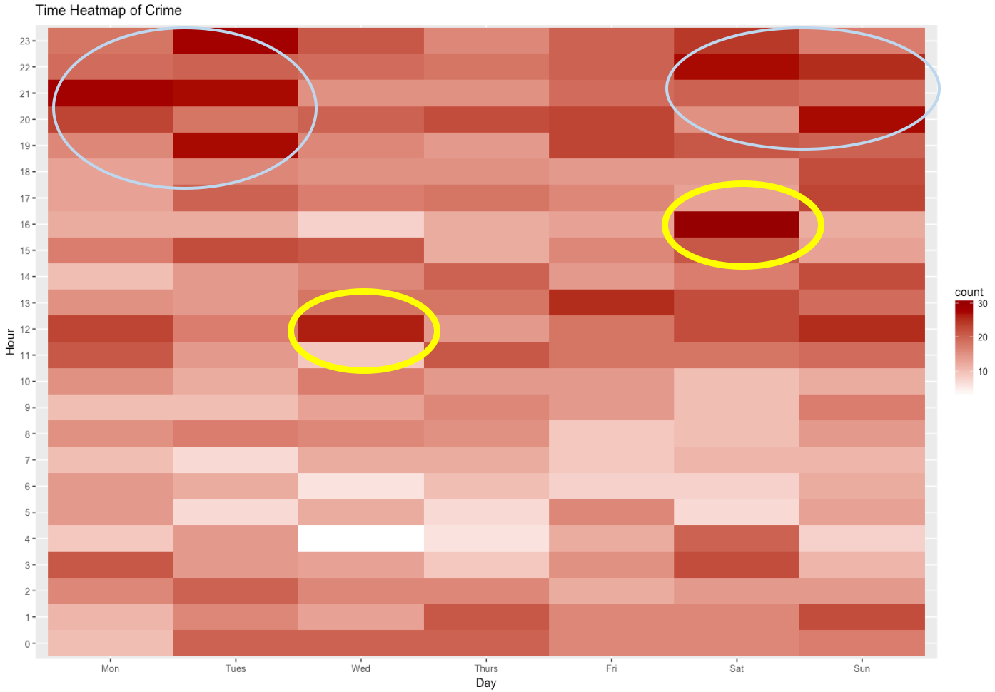

Chart 10 Crime Distribution by Time

Chart 10 shows crime distribution by time. X-axis is day of week, from Monday to Sunday. Y-axis is hour of day, from 12am to 11pm. The heatmap area represents number of crime. The darker the area, the more crimes happened during that time period. From this graph, we can see that most crimes happened on Monday, Tuesday, Saturday, and Sunday night, which makes sense because crimes usually happen during night. However, there are two abnormal time periods --- Wednesday 12pm and Saturday 4pm. So next, let us take a closer look at them to see what happened during those two time periods.

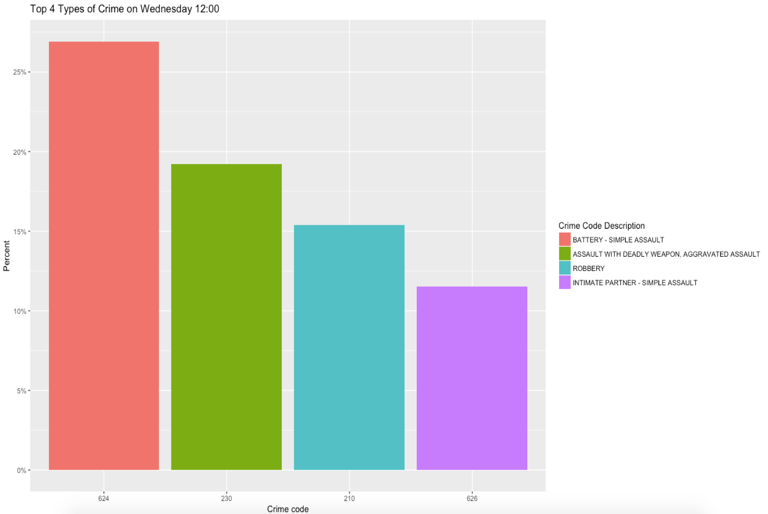

Chart 11 Top 4 Types of Crime on Wednesday 12pm

Top 4 types of crimes on Wednesday 12pm are “Battery”, “Assault with deadly weapon”, “Robbery”, and “Intimate partner”. Battery happened most frequently.

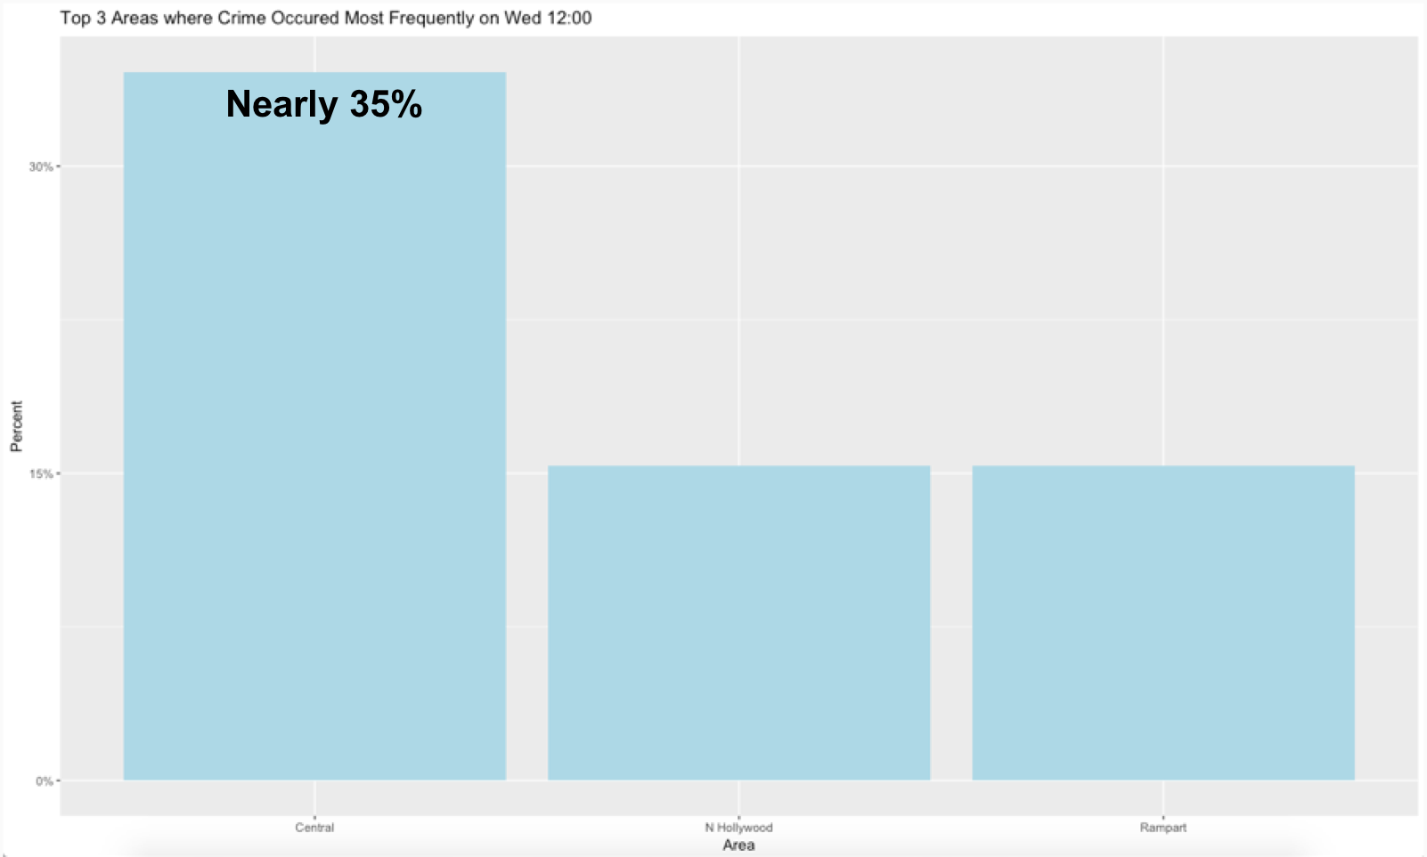

Chart 12 Top 3 Areas Where Crime Happened Most Frequently on Wednesday 12pm

Chart 12 shows the top 3 areas where crime happened most frequently on Wednesday 12pm. Nearly 75% of crimes happened in “Central Area”, “North Hollywood”, and “Rampart”. Central area takes up nearly 35% of the total crimes.

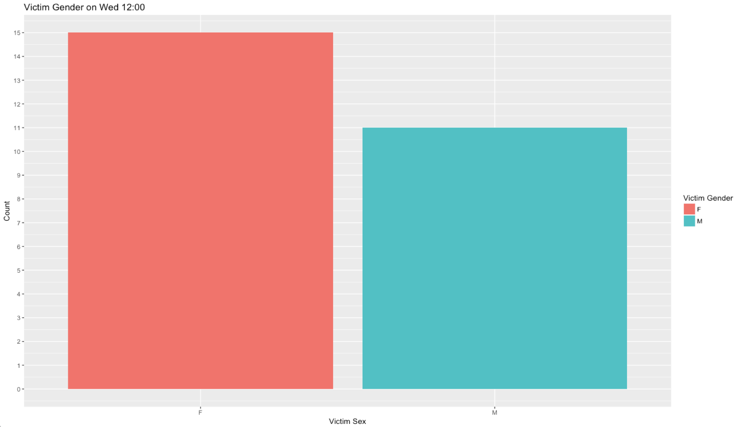

Chart 13 Victim Gender on Wednesday 12pm

On Wednesday 12pm, there are 15 female victims and 11 male victims, so there are more female than male victims.

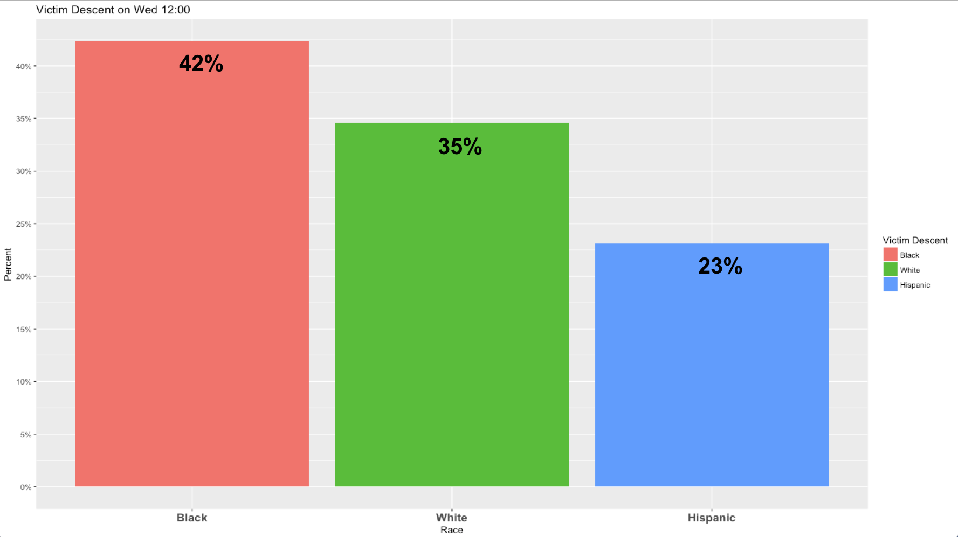

Chart 14 Victim Descent on Wednesday 12pm

Chart 14 shows victim descent on Wednesday 12pm. 42% of victims are blacks. 35% of victims are whites, and 23% of victims are hispanic. Blacks victims are the most.

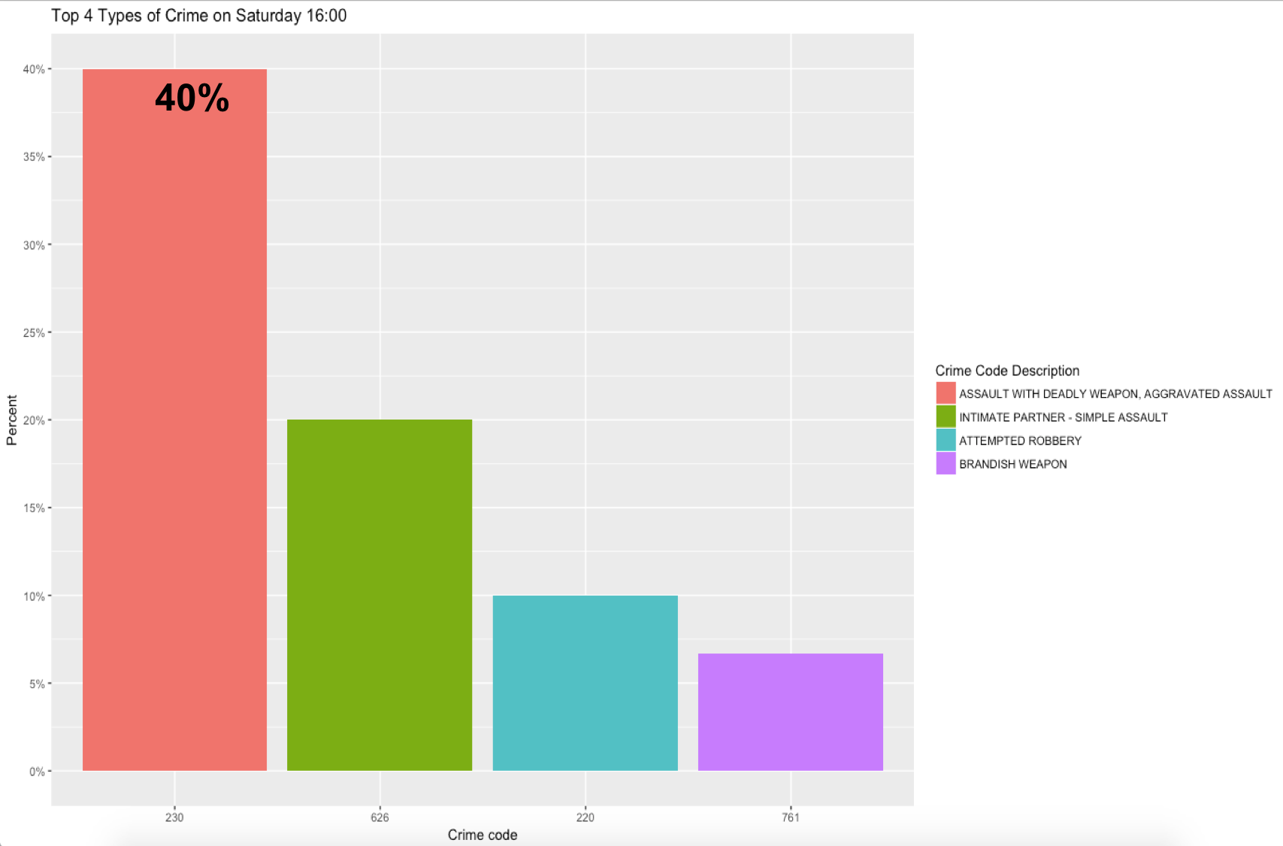

Chart 15 Top 4 Types of Crime on Saturday 4pm

The top 4 types of crime on Saturday 4pm are “Assault with deadly weapon”, “Intimate partner”, “Attempted robbery”, and “Brandish weapon”. We can see that “Assault with deadly weapon” takes up 40% of total crimes.

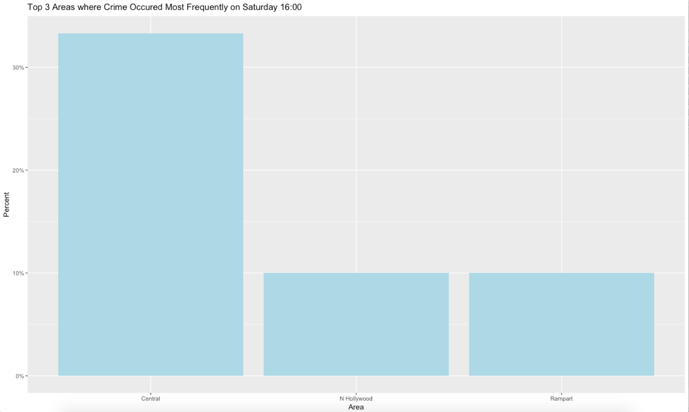

Chart 16 Top 3 Areas Where Crime Happened Most Frequently on Saturday 4pm

Chart 16 shows the top 3 areas where crime happened most frequently on Saturday 4pm. The top 3 areas are still “Central Area”, “North Hollywood”, and “Rampart”. Central Area takes up nearly 35% of total crimes.

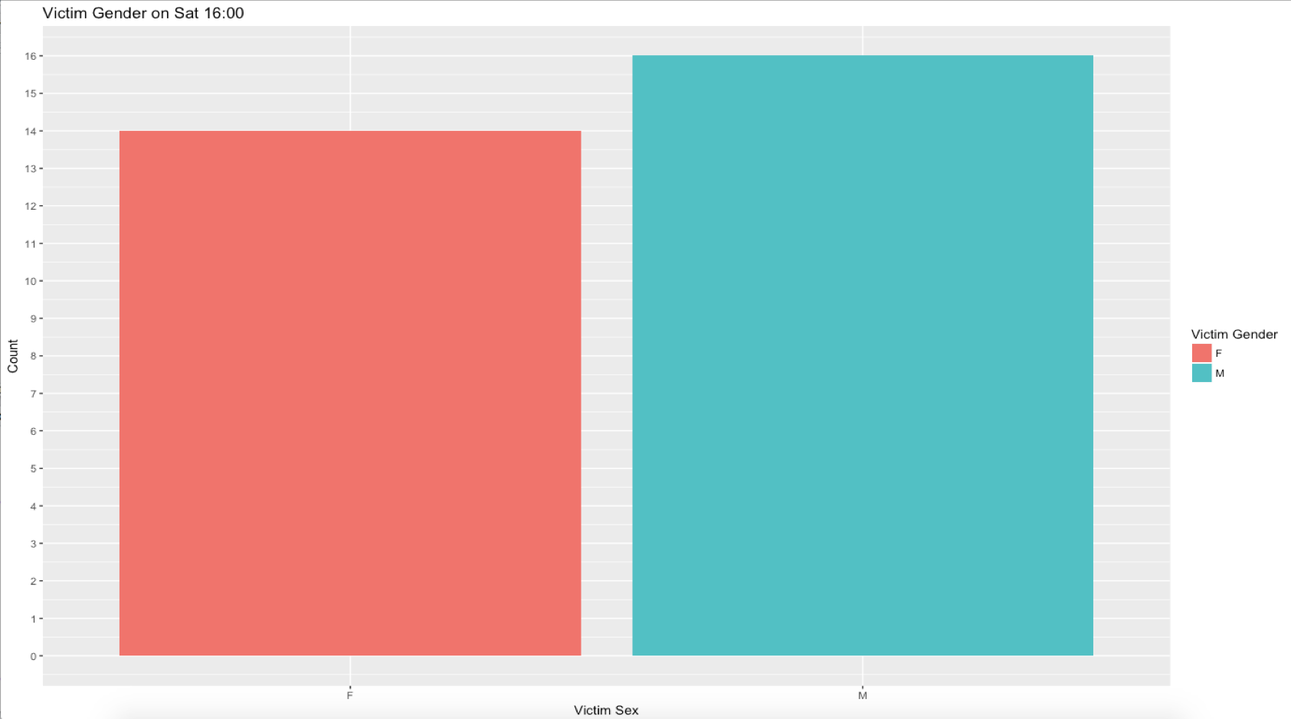

Chart 17 Victim Gender on Saturday 4pm

There are 14 female victims and 16 male victims on Saturday 4pm. The number of female and male victims are almost the same.

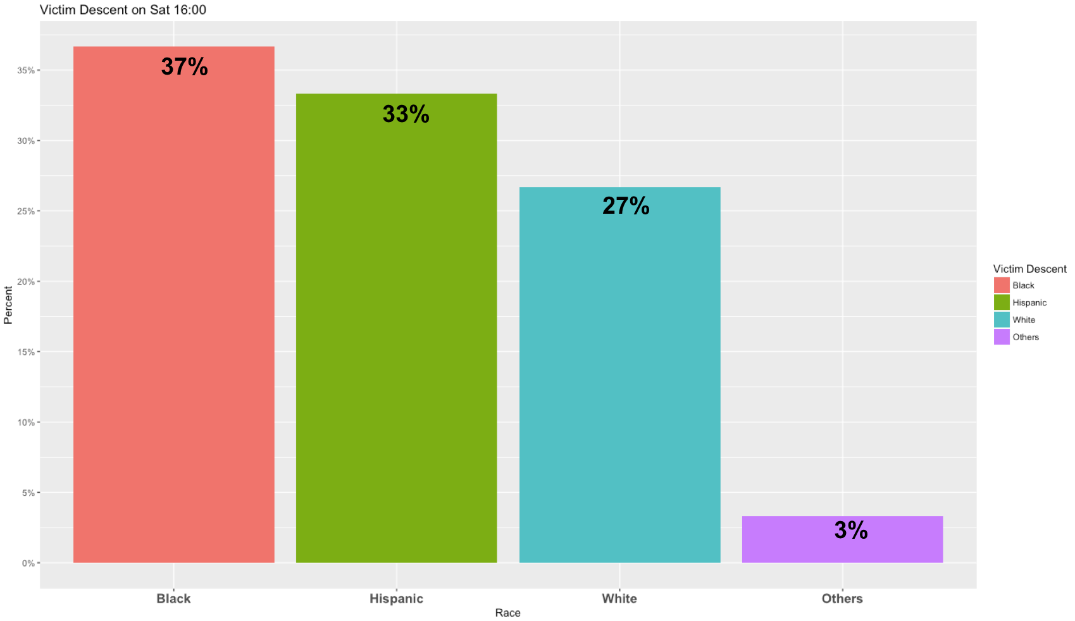

Chart 18 Victim Descent on Saturday 4pm

Chart 18 shows victim descent on Saturday 4pm. 37% of victims are blacks. 33% of victims are Hispanic, and 27% of victims are whites. Blacks victims are still the most, and blacks and Hispanic take up 70% of total victims.

In conclusion, data visualization of the crime dataset help us figure out some apparently patterns about the homeless crime. Based on our deep analysis about the crime data, we recommend that the City should

1. take a deeper look at what causes the high crime ratio in some specific communities
2. have some regulation enforcement or strengthen the police in specific areas such as “Central Area”, “North Hollywood”, and “Rampart” to prevent more crimes from happening.
3. get more attention to Wednesday 12pm and Saturday 4pm, besides the night period, due to their large number of crimes

# **Prediction**

1. **Predict Number of Homeless People in 2018**

From previous part, we found out there are some trends in number of homeless people among some communities. For example, there is a downward trend in Hollywood and an upward trend in South Central.

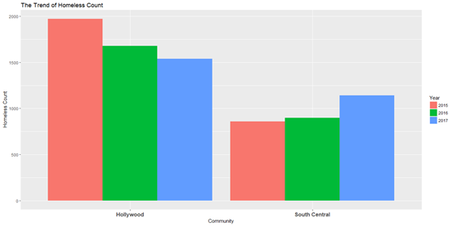

Chart 19 Trend of Homeless Count

Therefore, with a simple linear regression, we use the data from 2015-2017 to predict the number of homeless people in 2018. The equations are as follows,





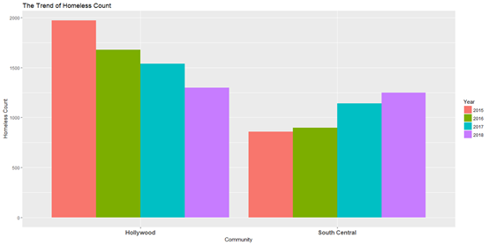

Chart 20 Predict Number of Homeless People in 2018

We predict the number of sheltered and unsheltered homeless people separately and sum them up for the total number of homeless people in 2018.

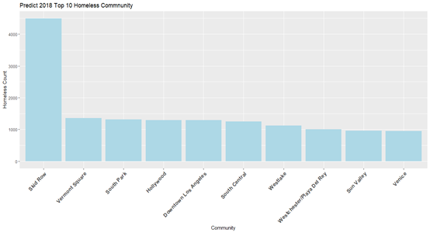

Chart 21 Predict Top 10 Homeless Community

Here is the predicted top 10 community with most homeless people. The composition is actually quite similar with the year of 2017 but the ranking is a little different. Hollywood falls from #2 to #4 because of its downward trend and there is a newcomer, Westchester/Playa Del Ray, in the top 10 list of 2018.

**Future Improvement:** We understand this is a naïve model, and the prediction may not be very precise because we only have 3 data points for each community. However, the accuracy can be lifted if we have more data (data before 2015) and include other predictors, such as macroeconomic index (GDP, CPI, etc.) and the growth rate of population for each community. Here, we just give an idea of what would happen if the current trend continues.

1. **Predict Number of crime in 2018**

Similarly, we try to predict of the number of crime in 2018. We built a multiple regression, using number of unsheltered and sheltered homeless people to predict the number of crime.

Linear Multiple Regression Model:



* Y = 2017 Number of Crime By Community
* X1 = 2017 Number of Unsheltered Homeless People
* X2 = 2017 Number of Sheltered Homeless People

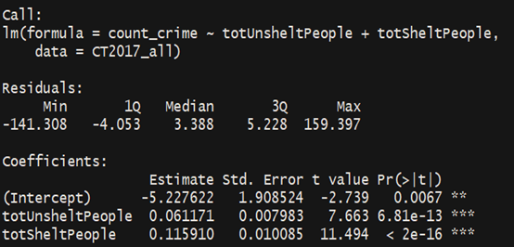

Table 2 Regression Model Results

Here is the result of our model, both two variables, Number of Unsheltered Homeless People and Number of Sheltered Homeless People, are statistically significant.

Then, we use the predicted number of homeless people in 2018 from previous section to predict the number of crime in 2018.

Predict 2018 Number of Crime：



1. = 2018 Predicted Number of Unsheltered Homeless People
2.  = 2018 Predicted Number of Sheltered Homeless People
3. = 2018 Number of Crime by Community

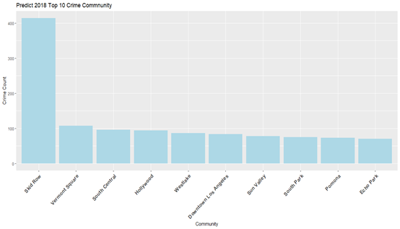

Chart 22 Predict 2018 Top 10 Crime Community

The result is highly correlated to the top10 homeless community. When there are more homeless people, there are the more crimes happening to them. Two exceptions are Pomona and Echo Park. They are not in the top 10 homeless community but they are in top 10 crime community.

# **Conclusion and Recommendation**

* + **For homeless pattern:**

1. Homeless people are mainly concentrated in downtown L.A, most of top 10 homeless communities are also concentrated in downtown in L.A
2. From 2015 to 2017, the number of homeless people have kept stable, while the community Skid Row has the largest number of homeless people, far more than other communities, which is our targeted rescuing area
   * **For crime:**
3. Take a deeper look at what causes the high crime ratio in some specific communities
4. Have some regulation enforcement or strengthen the police in specific areas such as “Central Area”, “North Hollywood”, and “Rampart” to prevent more crimes from happening.
5. Get more attention to Wednesday 12pm and Saturday 4pm, besides the night period, due to their large number of crimes
   * **For model building and predictions:**
6. We need sufficient data
7. Visualizations help us read the data but it takes more time to dig out the story behind.
8. Building models help us solve the potential issues we found through visualization, but it requires more data to make it more realistic.